Department of Computer Science and Engineering (Data Science)
CSDS-A | Batch A7 (CSE - Data Science, Section A)
SHEGUARD: AI Powered Women's Safety Platform
S.No. | Student name | Roll / hall ticket no.
1 | CH.AARTHI | 23K91A6741
2 | D.PRANATHI | 23K91A6748
3 | BALA VIGNESH | 23K91A6717
4 | A.VISHAL | 23K91A6704
Under the guidance of: [GUIDE NAME], [DESIGNATION]
SCOPE AND LIMITATIONS
This document states what SHEGUARD covers and what it deliberately does not, the assumptions behind the design, and the honest limitations of the system and of the evidence for it.

1 Scope of the Project

1.1 In scope
- User registration and login with bcrypt-hashed passwords and a signed token, and a profile of trusted guardians (name, phone, email, Telegram chat id).
- Safe Route: place search, route alternatives from the public OSRM server, a 467-district risk table from K-Means (k = 3) on district-level crimes-against-women data for 2001-2012, a per-route risk score with a night multiplier, and a map with a risk layer.
- Emergency activation by a one-tap SOS button or by a SafePhrase heard through the browser's speech recognition, with sensitivity levels and hold-for-three-seconds cancellation.
- A live location session that streams the user's position about every four seconds to a read-only tracking page over a WebSocket, with no guardian login.
- Alert messages to guardians by Telegram and email (implemented, but not exercised with real credentials in this work).
- Evidence capture: photograph and audio clip saved with timestamp, location and SHA-256 hash.
- A safety assistant that forwards questions to the Gemini API with a safety-focused system prompt.
- An installable progressive web application, a SQLite database of six tables, and an automated test suite with measured API latencies.

1.2 Out of scope
- A native Flutter application and a Supabase back end, which the batch abstract names; the platform is a React web application with a FastAPI and SQLite back end.
- Postgres Row Level Security and an administrator or police role; access control is per-user filtering in the code.
- Automatic triggers such as shaking the phone, pressing the power button, fall detection or listening while the screen is off.
- Wearable hardware, IoT sensors, cab-vendor integration and deviation alerts of the kind designed in the base paper [1].
- Live police, crowd or lighting data, population-normalised crime rates, and any validation of the risk tiers against real incidents.
- Video evidence, cloud storage of evidence, and integration with official emergency services; the application tells the user to call the emergency number and does not call it.
- Production hardening such as HTTPS termination, rate limiting, a hosted database, migrations and load testing.

1.3 Assumptions
- The user's browser is Chrome or Edge (for speech recognition), has location permission and a network connection, and the page is open in the foreground.
- A guardian has a Telegram chat id, an email address, or the tracking link by some other route; delivery of the link is best-effort.
- District-level crime counts for 2001-2012 are an acceptable, if coarse and old, proxy for the relative exposure of an area.
- The application runs on one machine with a single SQLite database for one demonstration deployment, and the public OSRM and Nominatim servers are available.

2 System Boundary
The two diagrams below show the boundary of SHEGUARD: what flows across it (context diagram) and who may do what inside it (use-case diagram).
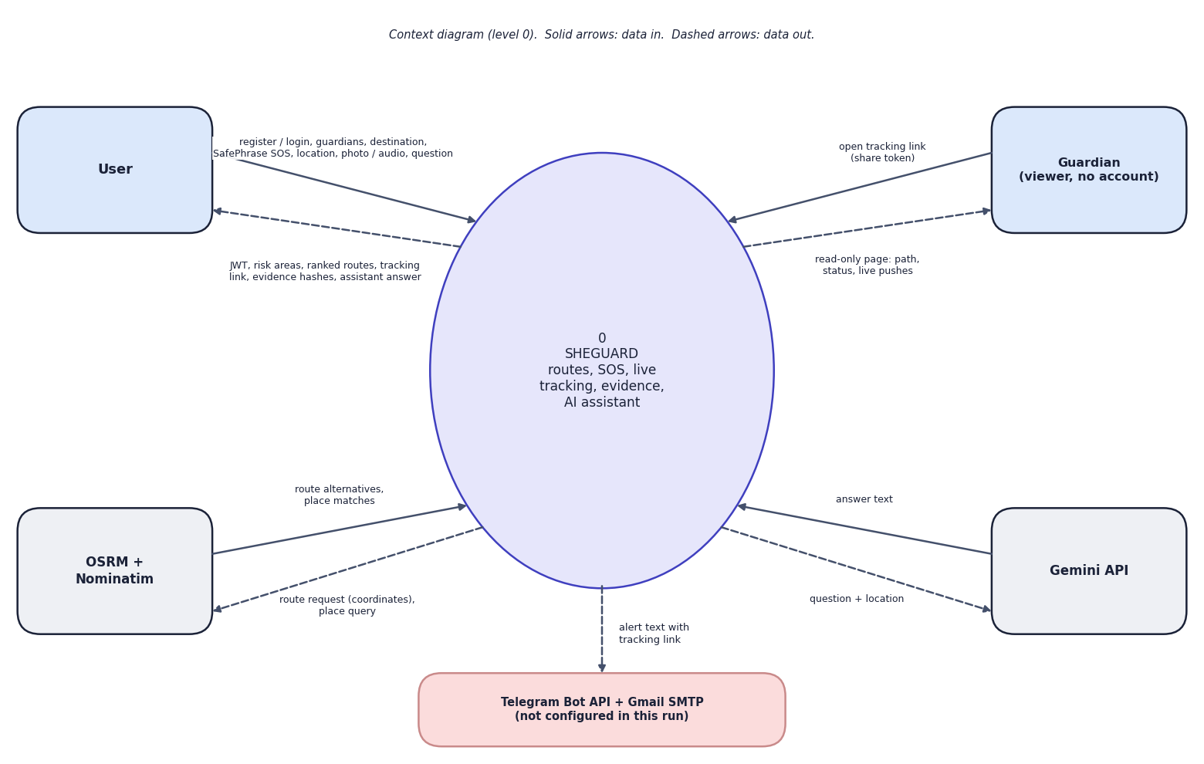
Fig. 1: Data-flow diagram, level 0 (context)
At the highest level SHEGUARD is one process with five external entities. The user sends registration and login details, guardians, a destination, the device location, a SafePhrase or tap that starts an SOS, photo or audio evidence and questions for the assistant; the user receives a token, the risk areas, the ranked routes, the tracking link, the evidence hashes and the assistant's answer. The guardian, who has no account, sends only the share token (by opening the link) and receives a read-only page with the path, the status and live pushes. OSRM and Nominatim receive a route request or a place query and return route alternatives or place matches. The Gemini API receives a question with the user's approximate location and returns text. The process sends an alert text with the tracking link to Telegram and Gmail; both are shaded because they were not configured in this run.
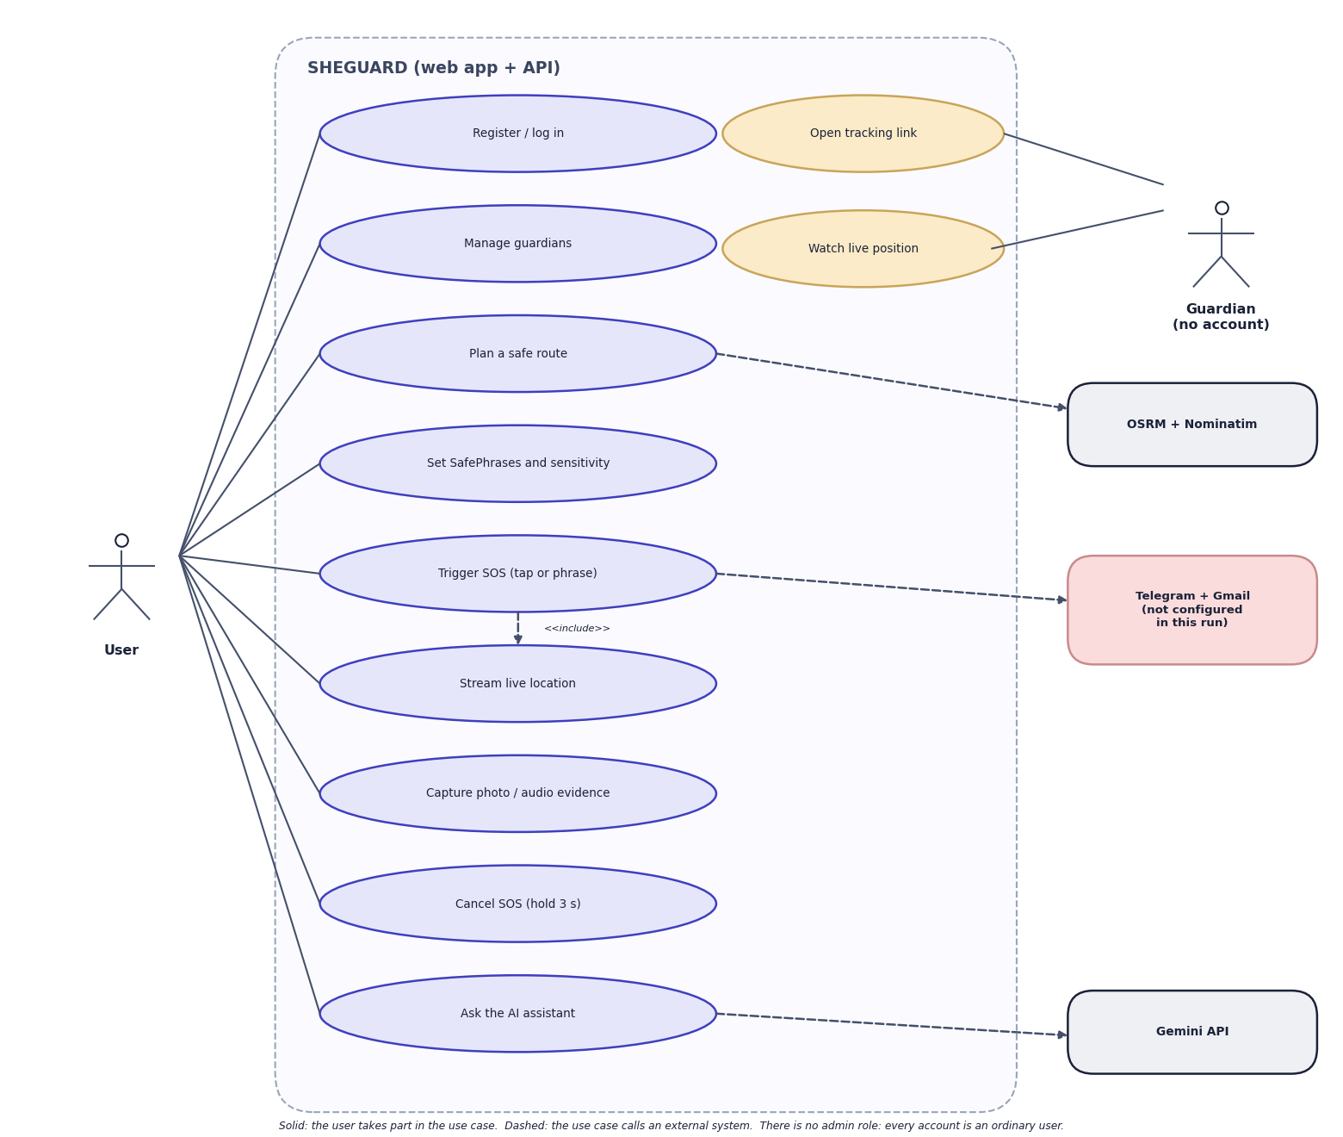
Fig. 2: Use-case diagram
There is one signed-in actor, the user. The user registers or logs in, manages guardians, plans a safe route, sets SafePhrases and their sensitivity, triggers an SOS by tap or phrase, streams the live location, captures photo or audio evidence, cancels the SOS by holding the button for three seconds and asks the AI assistant. Triggering an SOS includes streaming the location. The guardian is the second actor and has no account: the guardian can open the tracking link and watch the live position. The dashed arrows show which use cases call an outside system: route planning calls OSRM and Nominatim, the SOS calls Telegram and Gmail (not configured in this run) and the assistant calls Gemini. There is no administrator role: every account is an ordinary user.

3 Limitations and Assumptions
- Old, coarse, count-based data. The risk table uses district counts for 2001-2012, not rates per population, and 40% of the counted crimes are cruelty by husband or relatives, which says little about street safety. Populous and well-reporting districts rank high.
- Partial geocoding. Only 467 of 827 district entries (56.5%) were geocoded; Uttar Pradesh, West Bengal, Delhi, Uttarakhand and Tripura have none. The nearest district to Hyderabad is 149.0 km away and to Lucknow 231.3 km, and the scorer has no distance limit.
- One-feature clustering without ground truth. The tiers are two thresholds on one number, fitted on all 467 points with no held-out set and no validation against incidents. Assignments near the cut-offs move with the K-Means initialisation (adjusted Rand index against the shipped tiers: minimum 0.659, mean 0.790 over 30 runs).
- The night multiplier does not change the recommendation. It scales every route by the same factor (16 of 16 pairs unchanged), and 6 of 16 trips returned only one route.
- Alert delivery and the assistant were not demonstrated. The Telegram and Gmail credentials were empty, so every delivery reports not sent; the Gemini key returned quota errors (0 of 10 probes answered), and a provider timeout returns a 500 error.
- SafePhrase accuracy is unknown on real speech. The matcher was tested on written transcripts only; the browser's recogniser accuracy was not measured, and it needs an open Chrome or Edge tab and an online service.
- Defects found by testing. Stored evidence files can be fetched without a token if the link is known; there is no upload size limit, no login lockout, no check of coordinate ranges, and no check of a WebSocket token; the tracking page keeps its location trail after a session ends.
- Differences from the abstract. There is no Flutter application, Supabase service, Row Level Security or automatic Smart SOS trigger; the application is a browser-based progressive web app.
- Single machine, single database, no load, concurrency or penetration testing, no test on real phones or with a screen reader, and no user study.
- No numeric comparison with the base paper. It reports anticipated outcomes and cluster-selection tables on multi-feature data; SHEGUARD reports measurements on one feature.

4 Advantages and Constraints
Table 1: Advantages and constraints of the project
Advantages | Constraints
Runs on one laptop with no GPU and no paid service | Risk score is a one-feature clustering of 2001-2012 district counts; it cannot be validated
One platform joins safe routes, hands-free trigger, live tracking, evidence and an assistant | Only 467 of 827 districts are geocoded; several large cities have no nearby district
Guardians need no account: a link opens a live, read-only page | The tracking link never expires and evidence files are fetchable by URL
Every user's data is scoped to the owner (verified by probes) | No Row Level Security, no administrator role, a single user role
Evidence is stored with time, place and a SHA-256 hash | No verification endpoint; no upload size limit
Measured latencies are low (2 ms to 31 ms median for most routes) | Telegram, Gmail and Gemini were not working in this run; single-process SQLite, no load test

5 Limits of the Testing Done
- The risk model has no ground truth: silhouette 0.580 and Davies-Bouldin 0.531 describe how well one number separates into three groups, not how well the tiers predict danger on a street. No correlation with real incidents, and no population-normalised comparison, was measured.
- The data are district counts for 2001-2012, 56.5 % of districts were geocoded, 11 of 35 states and union territories have no district in the table (including Uttar Pradesh, West Bengal and Delhi), and the nearest district to Hyderabad is 149 km away; route scores in uncovered areas reflect a distant district.
- The route scorer was exercised on 16 real city pairs, of which six had no alternative route; recommended routes cost on average 3.7 extra minutes when there was a choice, and the night factor cannot change the choice at all.
- The SafePhrase results are on hand-written transcripts of two phrases. They say nothing about speech-recognition accuracy, accents, background noise, a locked phone or a backgrounded browser tab.
- The AI assistant was never observed returning an answer in this run (quota error 429, earlier 503 and a read timeout); its behaviour, including the SOS-first rule for emergencies, is untested. The Telegram and Gmail alert channels were never run with real credentials.
- The 57 automated tests use stubs for all outside services and a temporary database; there are no automated front-end tests, no load or concurrency tests beyond five WebSocket viewers, no penetration tests, no iOS Safari or screen-reader check and no test over a real phone and mobile network.
- Position and microphone input in the browser walk-through were injected by the test script (fixed city centres and a test tone), the evidence photo is one of the application's own screenshots, and all timings come from one machine that was not idle.
- No user study was carried out. Six defects are recorded as expected failures; the further weaknesses (public evidence URLs, no login lock-out, a trail that never expires, an unbounded nearest-district lookup, a blocking e-mail call) were found by probing or reading the code.

6 Limits of the Results
- No ground truth. The cluster indices (silhouette 0.58, Davies-Bouldin 0.53) measure separation of one number, not agreement with real danger; no train/test split exists and no field validation was done.
- Old, coarse data. The district file covers 2001-2012, counts are not per head of population, 56.5% of districts are geocoded and several large states are missing.
- Written transcripts, not speech. The SafePhrase figures test the matching rule on hand-made text; the recogniser was not measured.
- Injected position and stand-in media. The screenshots use a position set by the test script, a test-tone microphone and the application's own screenshot as the photograph; no phone, GPS or camera was used.
- Unverified channels. Alert delivery by Telegram and e-mail and the Gemini assistant could not be demonstrated returning results in this run.
- Small single-machine measurements. Timings come from one desktop with sequential calls (5 to 30 per endpoint), one client and no concurrent load; no user study was carried out.
- No numeric comparison with the base paper is possible, as explained in the section Comparison with the Base Paper.

